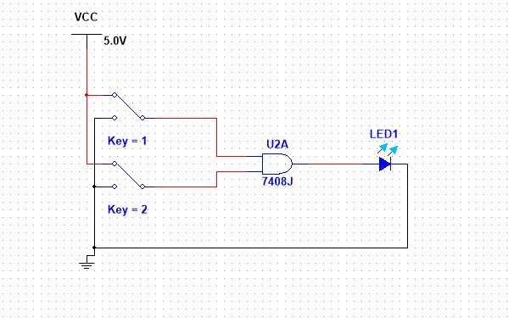
Multisim circuit:
AND-Gate Circuit:
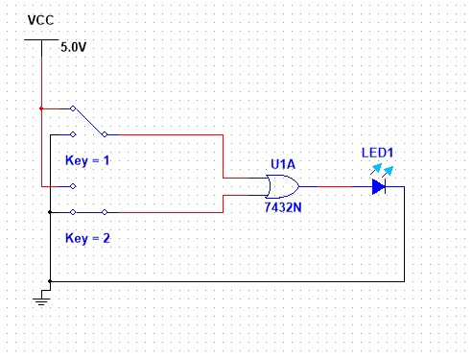
OR-Gate Circuit:
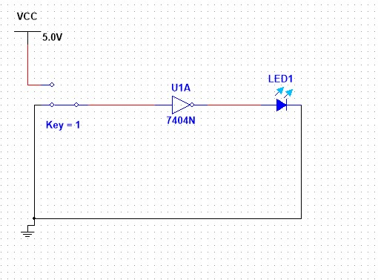
Not-Gate Circuit:

Multisim Circuit:
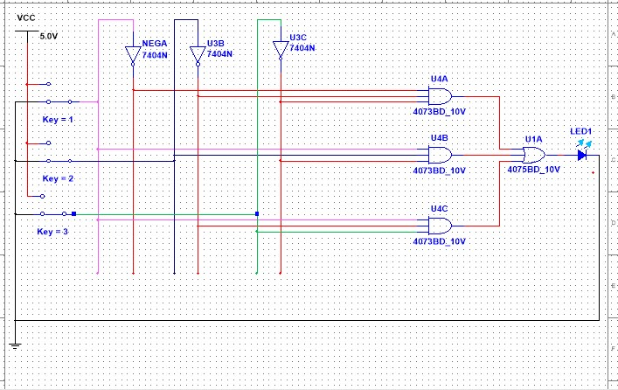
Boolean Expression(Y=A’B’C’+AB’C’+AB’C)

Multisim Circuit:
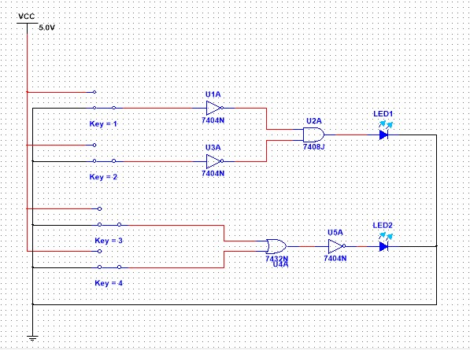
De-Morgan’s Law (A’. B’) = (A+B)’

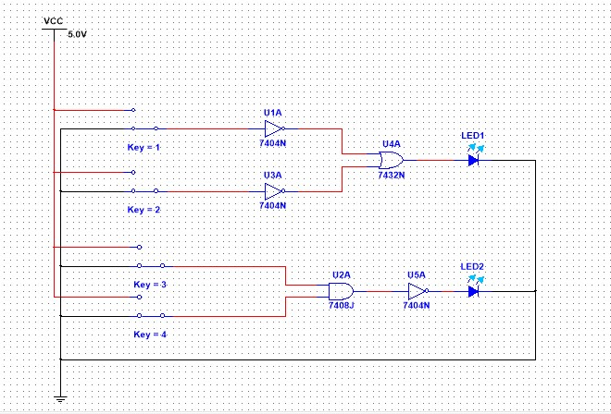
De-Morgan’s law A’+B’ = (A.B)’

Multisim Circuit:
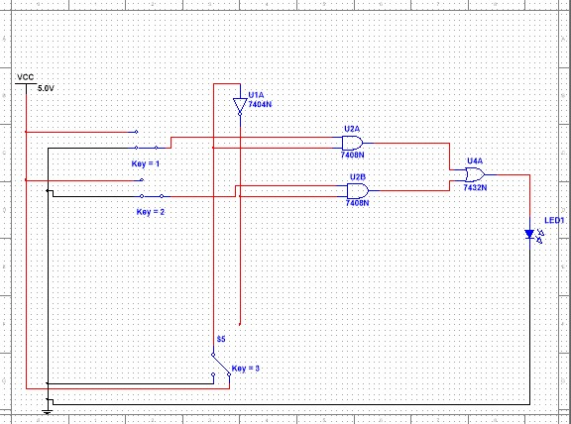
Multiplexer 2x1:
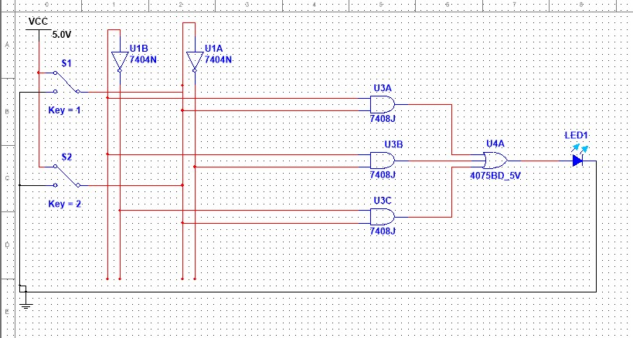
Decoder 2x4(using AND-Gates):

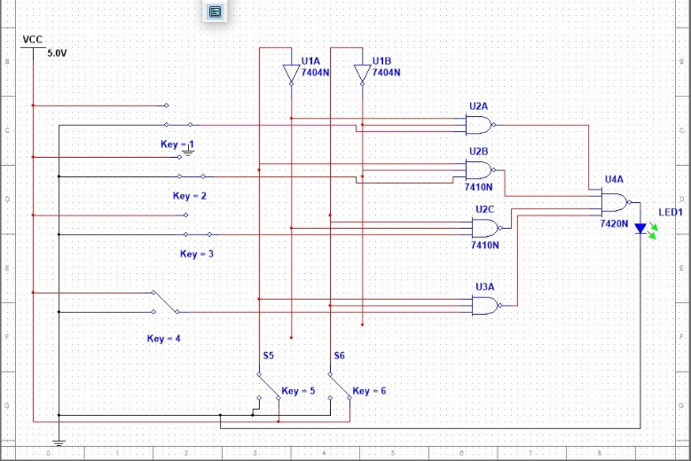
Decoder 2x4(using NAND-Gate):

